Ave Maria College

**COLLEGE OF EDUCATION**

HEI Unique Institutional Identifier: 09077

**SC 1 Teaching Science in the Elementary Grades** (Biology and Chemistry)

|  |
| --- |
| ***To my students:***  ***You are now on the 2nd week of this course.* *Before you start working on the lessons for this week make sure that you have submitted to your course facilitator the requirements of Week 1.***  ***For this week you will learn Lesson 3. Read and watch the learning materials below then answer the Comprehension Check questions and do Activity No. 4 and 3D Model No. 1.*** |

**Lesson III – Biology**

Living organisms have certain things in common. Biology is the study of life. Biologists recognize that all living organisms share certain general properties that separate them from non-living things. Every living organism is composed of one or more cell, is able to reproduce, and obtains and uses energy to run the process of life. Living organisms also maintain a constant internal environment and pass on traits to offspring. Responding and adjusting to the environment as well as growing and developing are the other characteristics shared by all living organism.

**A - Properties of life**

* Cellular organization
* Reproduction
* Metabolism
* Homeostasis
* Heredity
* Responsiveness
* Growth and development

**Seven Themes Unify the Study of Biology**

1. **Cellular structure and function** – all living things are made up of one or more cells. **Cells** are highly organized, tiny structures with thin coverings called membranes. A cell is the smallest unit capable of all life functions. The basic structure of cells is the same in all organisms, although some cells are more complex than others. Some organisms have only a single cell, while others are multicellular. Your body contains more than 100 trillion cells.
2. **Reproduction** – all living things can reproduce. Reproduction is the process by which all organisms make more of their own kind from generation to the next. Example, rapidly growing bacteria divide into offspring cell approximately every 15 minutes. Since no organism lives forever, reproduction is an essential part of living.
3. **Metabolism** – living organisms perform many different chemical reactions in order to obtain and use energy to run the process of life. All living things use energy to grow, to move and to process information. Without energy, life soon stops. Metabolism is the sum of all chemical reactions carried out in an organism. Almost all the energy used by living organism is captured from sunlight. Plant, algae, and bacteria capture this solar energy and use it to make complex molecules in a process called **photosynthesis**. These molecules then serve as the source of energy, or food, for other organism. For example, humans eat plants or animals that eat plants. Energy flows from the sun to the plants, from these plants to plant-eating organism, and from plant-eating organism to meat-eating organisms.
4. **Heredity** – all living things are capable to pass on their characteristics or traits to their offspring through genes that are passed from parent to offspring each generation. **Genes** are set of inherited instructions for making proteins. Genes control when proteins are made and what proteins are made. These instructions, which are coded in a molecule called **deoxyribonucleic acid (DNA),** determine the organism’s traits. The passing of traits from parent to offspring is called heredity. Heredity is the reason children tends to resemble their parents. Sometimes damage causes genes to change. A change in the DNA of a gene is called mutation. Most mutation are harmful, but sometimes mutation help organism survive.
5. **Homeostasis** – all living organism must maintain a stable internal environment in order to function properly. Organisms respond to changes in their external environment, adjusting their processes accordingly. The maintenance of stable internal conditions in spite of changes in the external environment is called Homeostasis. An organism unable to balance its internal condition with its environmental conditions could become ill and die.
6. **Evolution** – the great diversity of life on Earth is the result of a long history of change. Change in the inherited traits of species over time is called evolution. A species is a group of genetically similar organisms that can produce fertile offspring. Because of mutation, individuals in a species are different. Those individuals with genetic differences that better enable them to meet the nature’s challenges are the ones that survive, reproduce, and become more common. Charles Darwin, the great nineteenth-century British naturalist, called this processes in which organisms with favorable genes are more likely to survive and reproduce Natural Selection. Darwin’s theory of evolution by natural selection is the essence of biology, providing a consistent explanation for life’s diversity. The many different species of animals, plants and other organisms on Earth today, including humans, are the result of a long process of evolution.
7. **Interdependence** – the organism in a biological community have evolved to live and interact with other organism. A biological community is a group of interacting organisms. Ecology is the science that studies the interaction of living organisms with one another and with the non-living part of their environment. Organisms are dependent on one another and their environment – they are interdependent. Interdependence within biological communities is the result of a long history of evolutionary adjustments. The complex web of interactions in a biological community is disrupted when the community is polluted and when individual specie becomes extinct, as is happening in much of the world today.

**The Scientific Process** is the logical process of learning facts through observation and experimentation from which certain conclusion or theories are drawn. The scientific investigations always progress by a rigid series of “either/or” steps called the scientific method. In each of these steps of two incompatible alternatives is rejected. It is as if trial and error testing inevitably leads through the maze of uncertainty that always slows the scientific progress. All scientific investigation can be said to have six stages.

1. Identification of the Problem
2. Collecting Observations – the heart of any scientific investigation is careful observation. Observation is the act of noting or perceiving objects or events by using one or more of the five senses.
3. Forming Hypothesis – a hypothesis is a proposed explanation that might be true hypotheses must be able to be tested by additional observation or experimentation. It is important to note that a hypothesis is not just a guess. A scientist makes an educated or informed guess based on everything that he already knows.
4. Experimentation or testing the hypothesis
5. Analysis and interpretation of data and results
6. Generalization or formation of conclusion**.**

**B – Cell (Basic unit of life)**

**HOW CELLS WERE DISCOVERED?**

Most cells are too small to be seen by our naked eye. Scientists became aware of cells only after microscopes were invented in 1600s. When the English scientist Robert Hooke used one of the first microscopes to observe a thin slice of cork in 1665, “a lot of little boxes”. These little boxes reminded him of the small rooms in which monks live, so he called them cells. Later Hooke observed the same pattern in the stems and roots of carrots and other plants. What Hooke still did not know, however, was that cells are the basic units of living things. Ten years later, the Dutch scientist Anton van Leeuwenhoek focused a microscope on what seemed to be clear pond water and discovered a world of living creatures.

Formation of the cell theory

* Robert Hooke’s discovery
* Anton van Leeuwenhoek’s discovery
* German Botanist Matthias Schleiden concluded that cells compose not only the stem and roots but every parts of a plant.
* German Zoologist Theodor Schwann made the same conclusion on animals.

**The Cell Theory**

1. All living things are composed of one or more cells.
2. In organism, cells are the basic units of structure and function.
3. Cells are produced only from existing cells.

**All cells share certain structural characteristics.**

1. All cells have plasma membrane or cell membrane

* It separates the cell’s content from the materials outside the cell.
* Regulates what moves in and out of the cell, helping it to maintain homeostasis

1. All cells have cytoplasm

* This is everything inside the cell except the cell’s genetic material.
* The fluid portion of the cytoplasm is called the cytosol
* The cytosol is packed full of free-floating ribosomes, the structure on which proteins are made.

1. All cells have the ability to reproduce themselves, and they all possess genetic material, which contains the instruction for making proteins and carrying out the cell’s day-to-day activities.

**History of cell**

The oldest fossils of cells are those of tiny cyanobacteria.

* Prokaryotic
* Lived at least 3.5 billion years ago.

Prokaryotes

* Single celled organism
* Lack internal membrane bound compartments.
* The term prokaryote is from the Greek words pro, meaning “before” and karyote meaning “kernel”.
* Without separate compartment that isolates materials, cells cannot carry out many specialized functions.
* The genetic material is a single, circular molecule that is not enclosed in a membrane-bound compartment.

Eukaryotes

* The first cell with internal compartments
* The term eukaryote is from the Greek words eu, meaning “true” and karyote meaning “kernel”.
* Have a nucleus- a membrane bound compartment that houses the cell’s DNA
* Possess other small, specific compartments called organelles that carry out specific functions. Such organization allows eukaryotic cells to function in more complex ways than do prokaryotic cells.

**How Eukaryotes evolved**

Most biologists who study eukaryotic cell structure think that eukaryotes evolved from prokaryotes. Many of the organelles of eukaryotes resemble bacteria, perhaps engulfed long ago by much larger cells. Scientist hypothesize that bacterial “trespassers” remained inside these cells, gradually losing their ability to live independently. These invading bacteria became organelles, and eukaryotic cells were the result. The fact that some organelles have their own distinctive DNA provides additional evidence for this hypothesis. All living cells that are not bacteria are eukaryotes. Your cells are eukaryotic, as are tree cells and elephant cells. The “animalcules” seen by van Leeuwenhoek also were eukaryotic.

**Multicellularity**

Early eukaryotes were single-celled, but eventually many of them became aggregated (clustered) into multicellular organisms. Multicellular organisms are those that are composed of more than one cell. Being multicellular was a great evolutionary advance because it enables particular cells to specialize in certain activities. You are a multicellular cell individual. Your body is composed of trillions of cells whose specialize activities are coordinated with one another.

Not all eukaryotes are multicellular. In fact, if you were to survive all living organisms on earth today, you would find that most living eukaryotes are unicellular protists, single celled organisms. Whether single-celled or multicellular, the cells of all eukaryotes are similar in design, more similar to each other than to the prokaryotes.

**Cells must be small**

There are some 100 trillion cells in the human body, typically ranging from 5 to 20 um in diameter. Why is your body made of many tiny cells instead of a few large cells? There are two limits that affect how efficiently cells work and that governs cell size. One limit is related to the exchange of materials between the inside and the outside of the cell, and the other limit is related to the distribution of materials within the cell.

Animal cells are eukaryotic cells, or cells with a membrane-bound nucleus. Unlike prokaryotic cells, DNA in animal cells is housed within the nucleus. In addition to having a nucleus, animal cells also contain other membrane-bound organelles, or tiny cellular structures, that carry out specific functions necessary for normal cellular operation. Organelles have a wide range or responsibilities that include everything from producing hormones and enzymes to providing energy for animal cells.

**C – General Plant and Animal Cell Organelles**

1. **Cell membrane**- it is the thin layer of protein and fat that surrounds the cell. The cell membrane is semi permeable, allowing some substances to pass into the cell and blocking others. Works like a screen.
2. **Centrosome**-(also called the ‘microtubule organizing center’) a small body located near the nucleus – it has a dense center and radiating tubules. The centrosomes are where microtubules are made. During cell division (mitosis), the centrosomes divides and the two parts move to opposite sides of the dividing cell. The centriole is the dense center of the centrosome.
3. **Cytoplasm-**a jellylike material outside the cell nucleus in which the organelles are located. Where the action takes place, where the nutrients are used.
4. **Golgi body-**(also called as the Golgi apparatus or Golgi complex) a flattened, layered sac-like organelle that looks like a stack of pancakes and is located near the nucleus. It produces the membranes that surround the lysosomes. The Golgi body packages proteins and carbohydrates into membrane-bound vesicles for “export” from the cell.
5. **Lysosome-**(also called cell vesicles) this are round organelles surrounded by a membrane and containing digestive enzymes. This is where the digestion of cell nutrients takes place.
6. **Mitochondrion-** it is aspherical to rod-shaped organelles with a double membrane. The inner membrane is in folded many times, forming a series of projections (called cristae). The mitochondrion converts the energy stored in glucose into ATP (adenosine triphosphate) for the cell.
7. **Nuclear membrane-** it isthe membrane that surrounds the nucleus.
8. **Nucleolus-**an organelle within the nucleus- it is where ribosomal RNA is produced. Some cells have more than one nucleolus.
9. **Nucleus-**It is a spherical body containing many organelles, including the nucleolus. The nucleus controls many of the functions of the cell (by controlling protein synthesis) and contains DNA (in chromosomes). The nucleus is surrounded by the nuclear membrane. It is the brain of the cell.
10. **Ribosome-**small organelles composed of RNA-rich cytoplasmic granules that are sites of protein synthesis.
11. **Rough endoplasmic reticulum-**(rough ER) a vast system of interconnected, membranous, infolded and convoluted sacks that are located in the cells cytoplasm (the ER is continuous with the outer nuclear membrane). Rough ER is covered with ribosome’s that give it a rough appearance. Rough ER transports materials through the cell and produces proteins in sacks called cisternae (which are sent to the Golgi body, or inserted into the cell membrane).
12. **Smooth endoplasmic reticulum-**(smooth ER) a vast system of interconnected, membranous, infolded and convoluted tubes that are located in the cells cytoplasm (the ER is continuous with the outer nuclear membrane). The space within the ER is called the ER lumen. Smooth ER transports materials through the cell. It contains enzymes and produces and digests lipids (fats) and membrane proteins; smooth ER buds off from rough ER, moving the newly-made proteins and lipids to the Golgi body, lysosomes, and membranes.
13. **Vacuole**- it is a fluid-filled, membrane-surrounded cavities inside a cell. The vacuole fills with food being digested and waste material that is on its way out of the cell.
14. **Cell wall**- supports and protects the cell. It consists of a mixture of proteins and carbohydrates, including the polysaccharide cellulose. It helps support and maintains the cell’s shape; it protects the cell from damage and connects the cell.
15. **Chloroplasts**- are organelles that use light energy to make carbohydrates from carbon dioxide and water.
16. **Central vacuole**- it stores water and may contain many substances, including ions, nutrients and wastes. When it is full it presses the cytoplasm against the cell wall, making the cell rigid. This rigidity enables a plant to stand upright.

**Watch:**

**Powerpoint 1 Cell** [**1. Cell.pptx**](1.%20Cell.pptx)

**Video 2** [**Video 2. Intro to Cell.mp4**](Video%202.%20Intro%20to%20Cell.mp4)

**Video 3** [**Video 3. Cell Structure.mp4**](Video%203.%20Cell%20Structure.mp4)

**Video 4** [**Video 4. Prokaryotic vs. Eukaryotic Cells.mp4**](Video%204.%20Prokaryotic%20vs.%20Eukaryotic%20Cells.mp4)

|  |
| --- |
| ***Keep in Mind:***  *Biology is the study of living things. All living things possess the seven properties of life: Cellular organization, Reproduction, Metabolism, Homeostasis, Heredity, Responsiveness and Growth and development. All living things are composed of one or more cells, cells are the basic units of structure and function. Cells are produced only from existing cells.* |
| ***Comprehension Check:***   1. Describe and summarize the formation of the cell theory. 2. What are the organelles present in all living organism? Describe their function.   ***To validate your answer, feel free to contact your course facilitator through any of the following:***   * Facebook: JP Valles * Contact No: 09350993964 * Email address: [teacherjohnpaul@gmail.com](mailto:teacherjohnpaul@gmail.com) |

Ave Maria College

**COLLEGE OF EDUCATION**

HEI Unique Institutional Identifier: 09077

**SC 1 Teaching Science in the Elementary Grades** (Biology and Chemistry)

Activity No. 4

**Concept Map of Cell**

**Name: ____________________________________________ Date: _________________**

**Course – Year & Section: _____________________ Score: ________________**

Directions: *Create your own Concept Map of Cell. Write a short description for each component of the concept map. Use arrows, bullets and numbering to show relationship.*

**CELL**

Ave Maria College

**COLLEGE OF EDUCATION**

HEI Unique Institutional Identifier: 09077

**SC 1 Teaching Science in the Elementary Grades** (Biology and Chemistry)

**3D Model 1 – Cell**

**Name: ____________________________________________ Date: _________________**

**Course – Year & Section: _____________________ Score: ________________**

Directions: *Using recyclable materials, construct your own three dimensional model of a cell with the following dimension: length 12 inches, width 15 inches and height 15 inches. Label each cell organelle properly. Colors will make your output more realistic.*

Sample image of a Plant Cell

Sample image of Animal Cell

|  |
| --- |
| ***To my students:***  ***Continue Lesson 3… Read and watch the learning materials below then answer the Comprehension Check questions and do Activity No. 5 and 3D Model No. 2.*** |

**D – Human Body Systems**

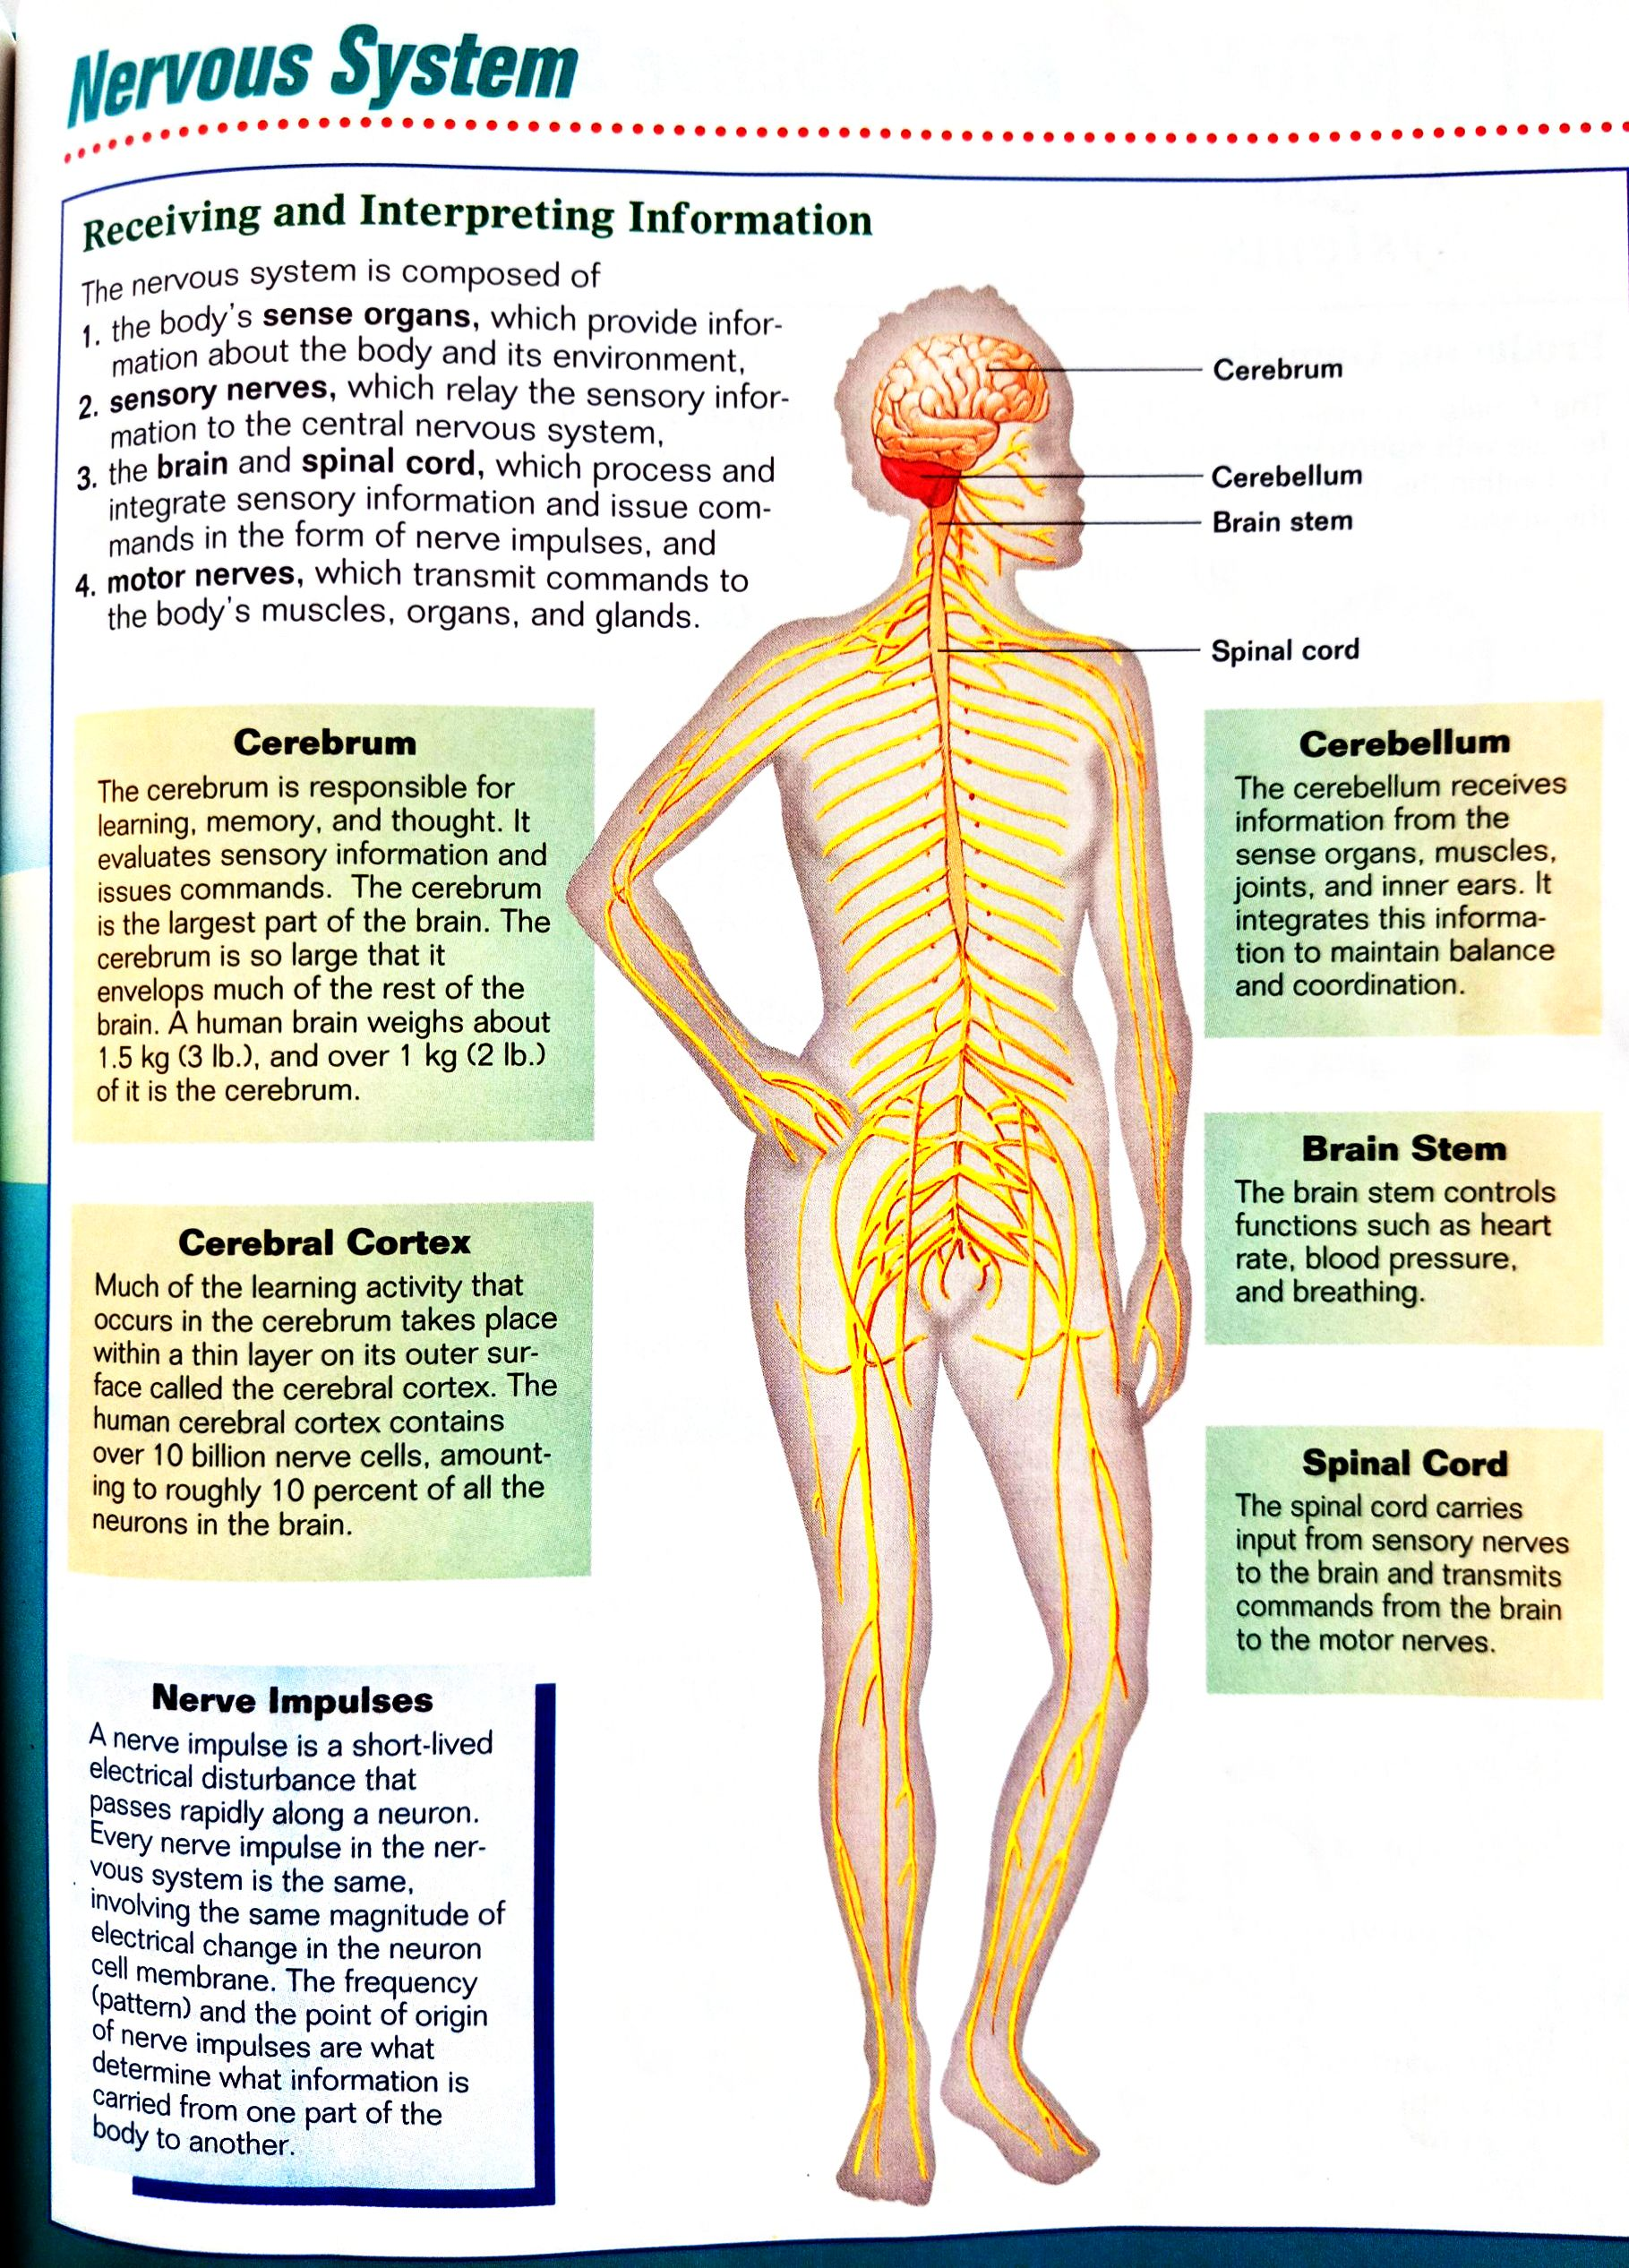**Watch Video 5:** [**Video 5. Human Body Systems Functions Overview.** **mp4**](Video%205.%20Human%20Body%20Systems%20Functions%20Overview.mp4)

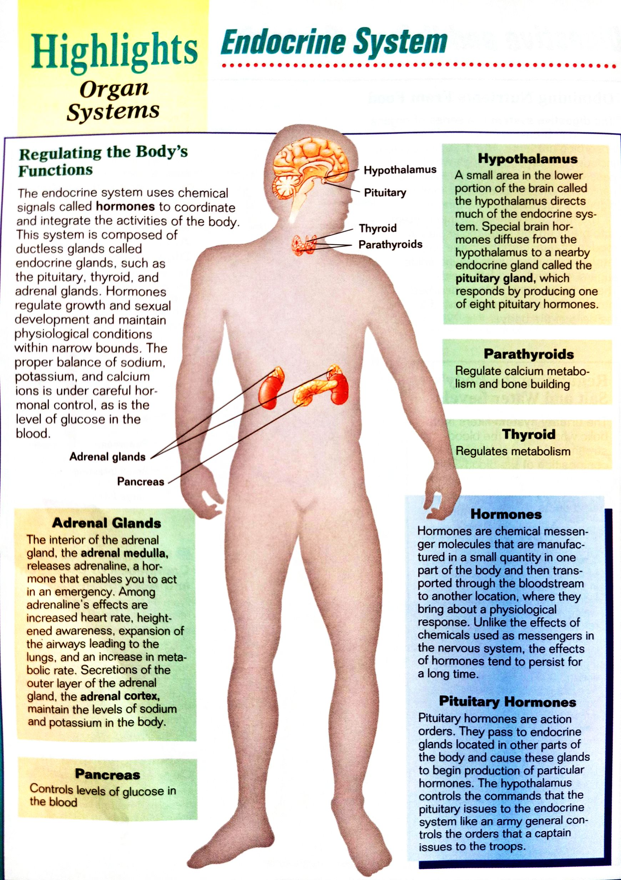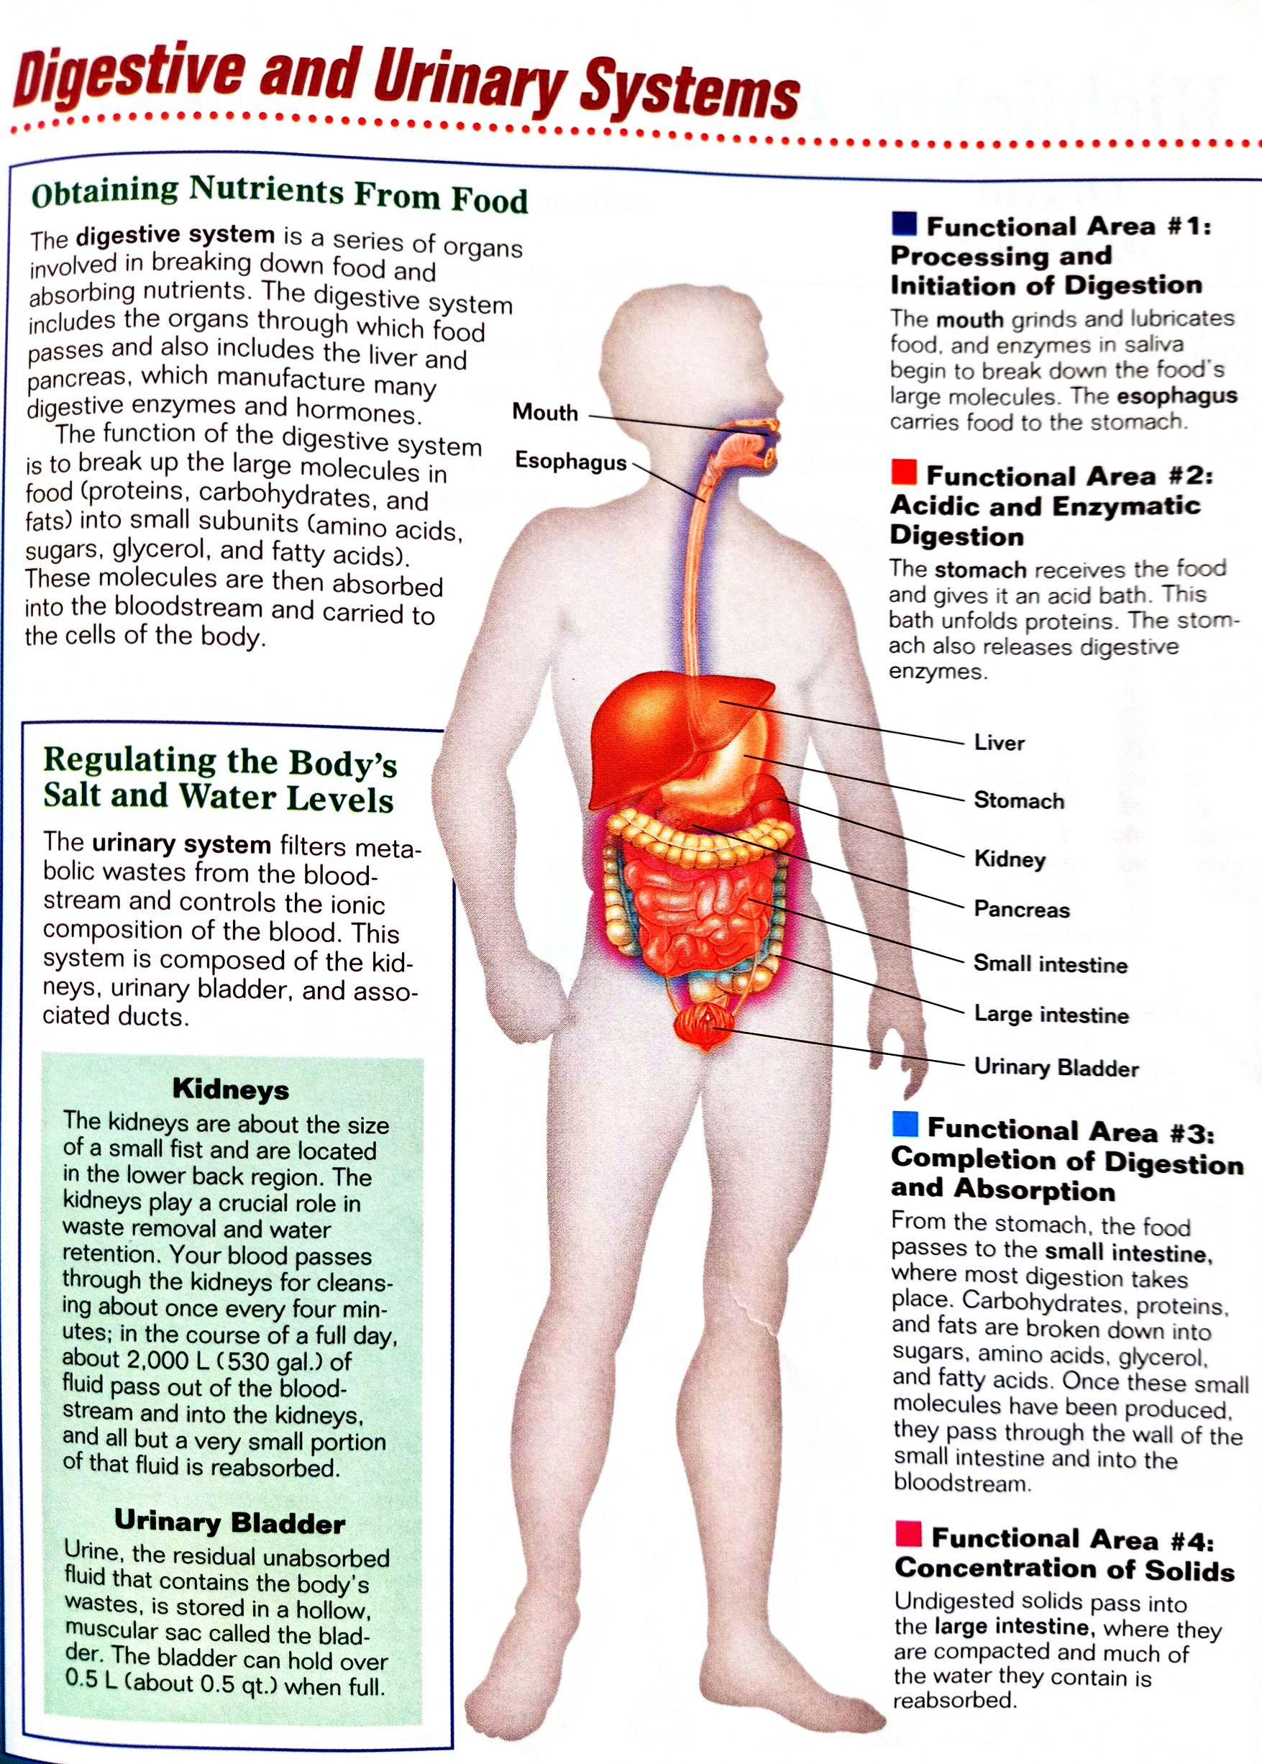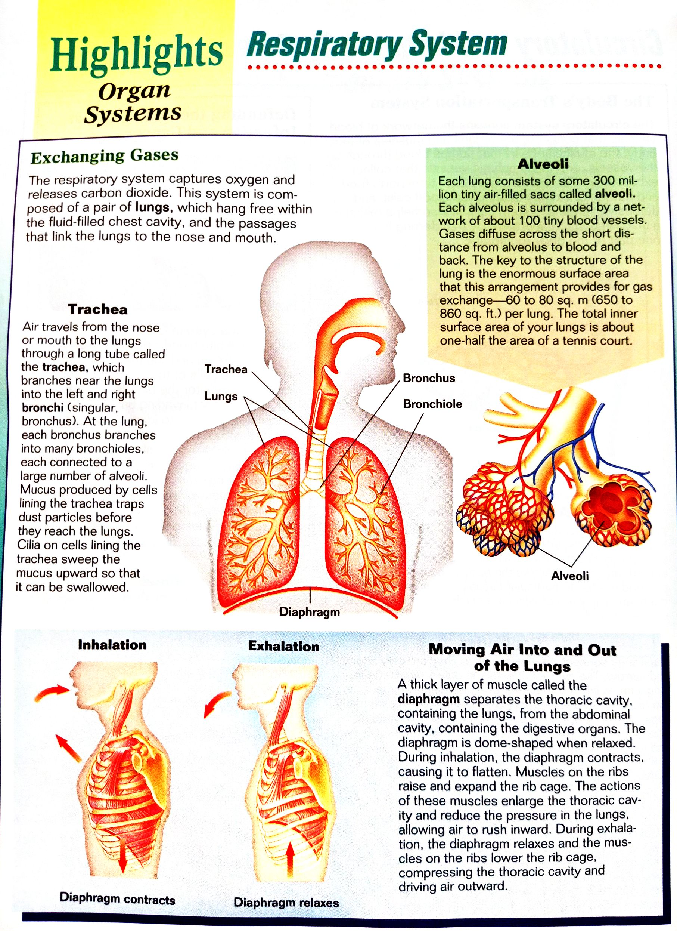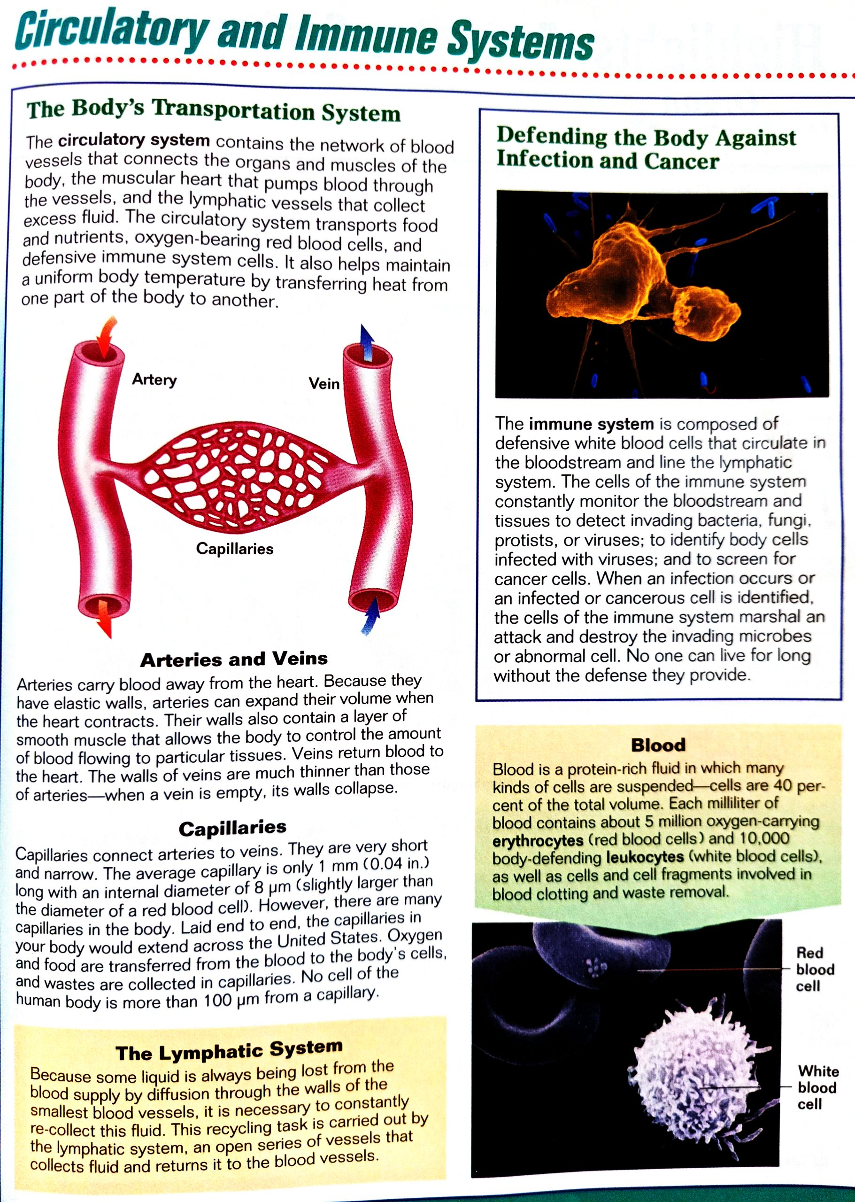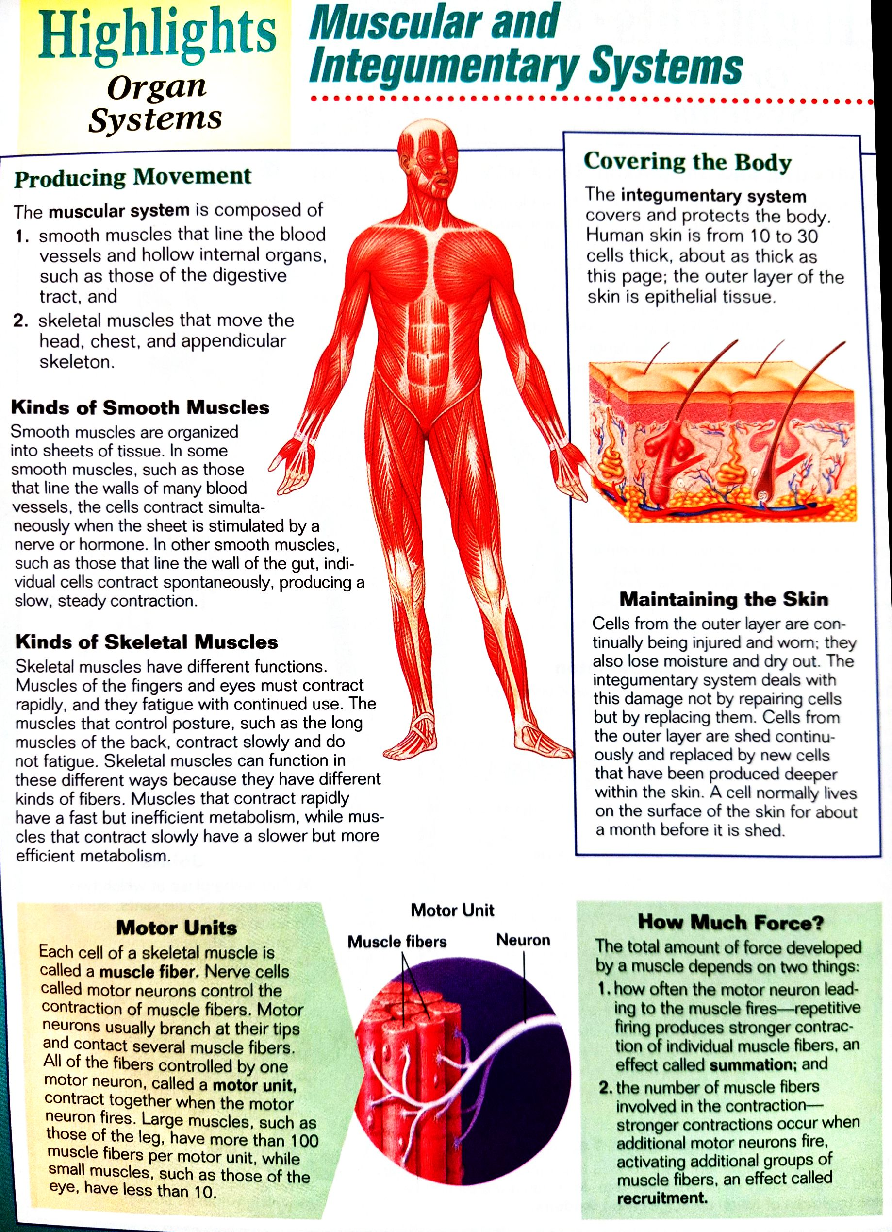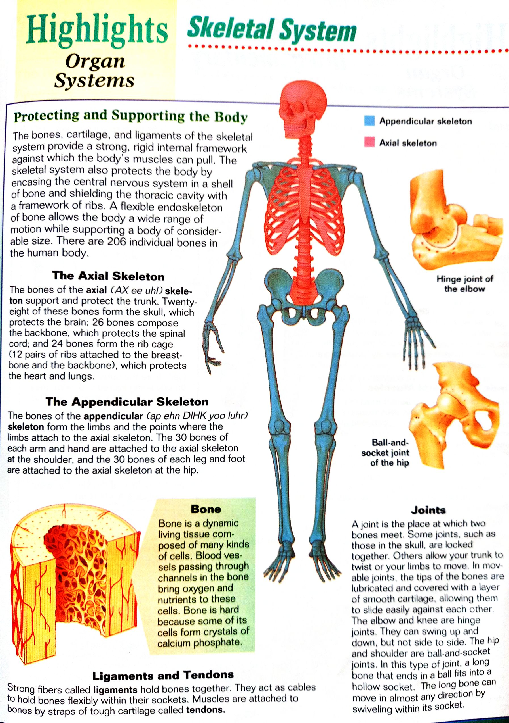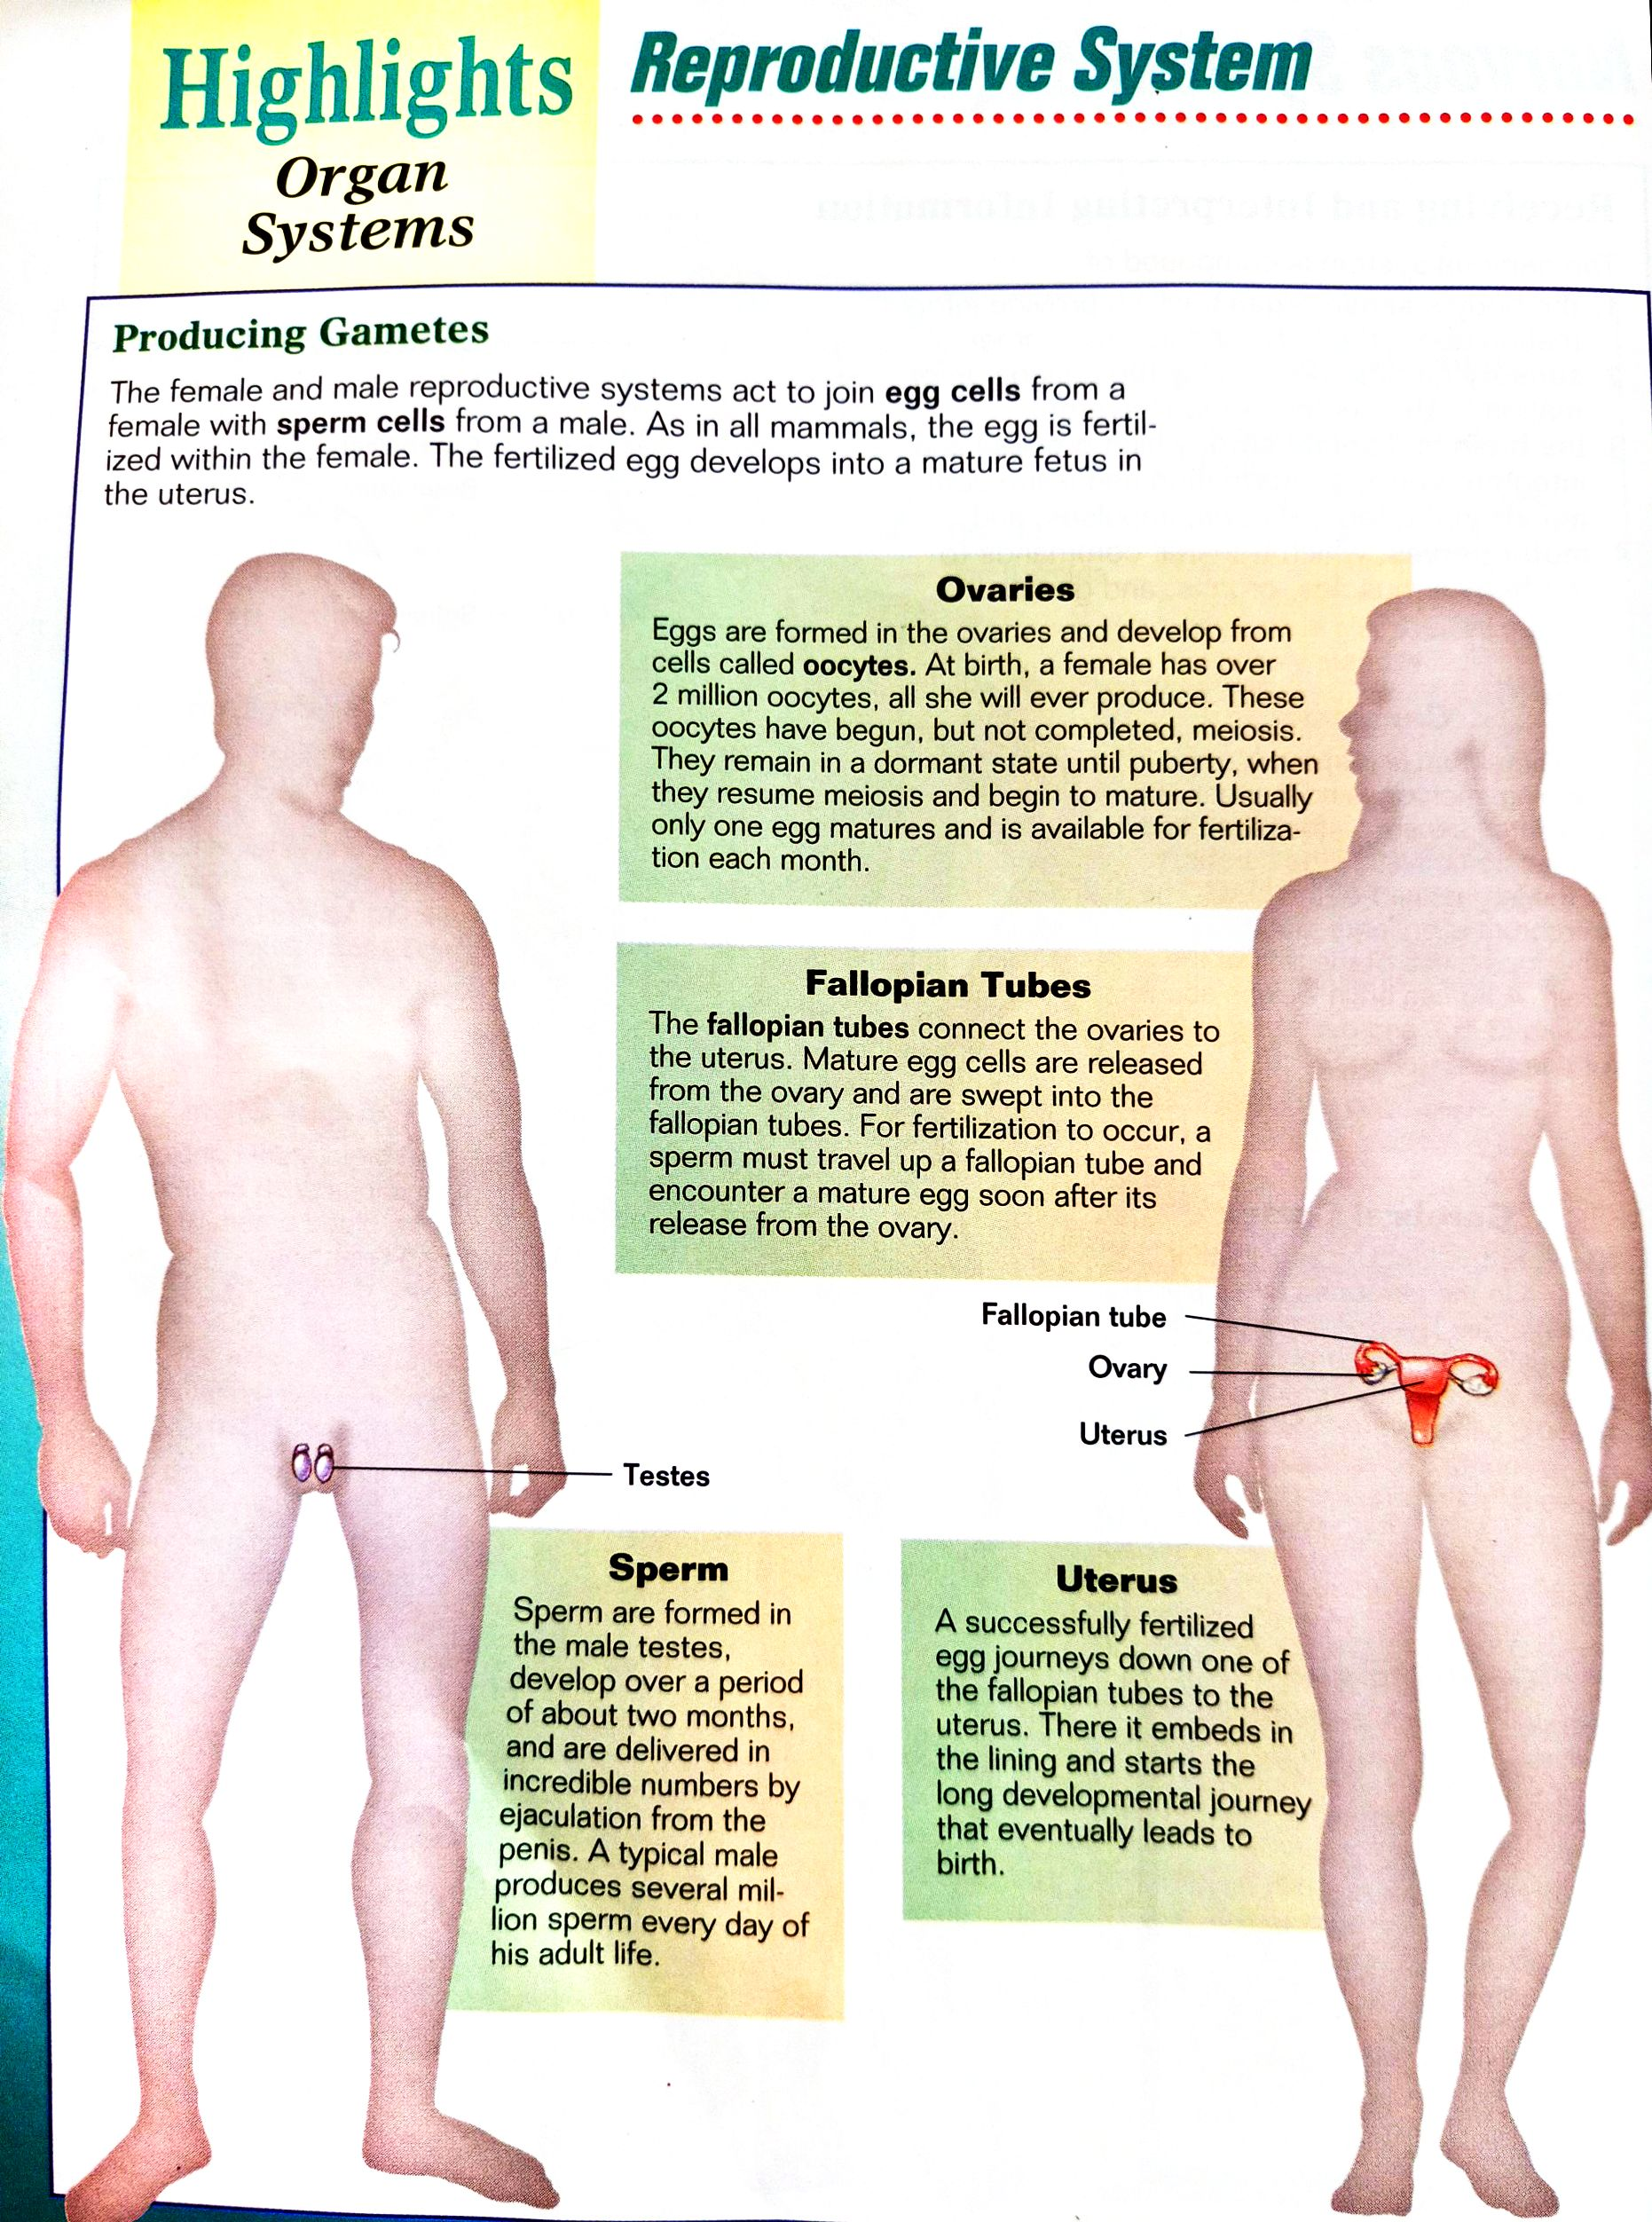

|  |
| --- |
| ***Keep in Mind:***  *Body systems are groups of organs and tissues that work together to perform important jobs for the body. Some organs may be part of more than one body system if they serve more than one function. Other organs and tissues serve a purpose in only one body system. Examples include the respiratory system, nervous system, and digestive system.* |
| ***Comprehension Check:***   1. *Discuss briefly the relationship or connection of all the body system of a human being.*   ***To validate your answer, feel free to contact your course facilitator through any of the following:***   * Facebook: JP Valles * Contact No: 09350993964 * Email address: [teacherjohnpaul@gmail.com](mailto:teacherjohnpaul@gmail.com) |

**List of References:**

Books:

Johnson, G. (1998), Biology Principles and Exploration, USA. Holt, Rinehart and Winston.

Site:

Amoeba Sisters (2016), Human Body Systems Functions Overview: The 11 Champions (Updated) retrieved on 5/14/2020 from <https://www.youtube.com/watch?v=gEUu-A2wfSE>

Amoeba Sisters (2016), Intro to cell, retrieved on 5/14/2020 from <https://www.youtube.com/watch?v=8IlzKri08kk>

Nucleus Medical Media (2015), Biology Cell Structure, retrieved on 5/14/2020 from <https://www.youtube.com/watch?v=URUJD5NEXC8>

Ave Maria College

**COLLEGE OF EDUCATION**

HEI Unique Institutional Identifier: 09077

**SC 1 Teaching Science in the Elementary Grades** (Biology and Chemistry)

Activity No. 5

**Human System Analysis**

**Name: ____________________________________________ Date: _________________**

**Course – Year & Section: _____________________ Score: ________________**

Directions: *Choose one human body system; enumerate all organs and components that constitute to this system with their corresponding roles and function. Use the template below.*

|  |  |
| --- | --- |
| System: | |
| Major Organs | Function |
|  |  |
| Minor Organs | Function |
|  |  |

Ave Maria College

**COLLEGE OF EDUCATION**

HEI Unique Institutional Identifier: 09077

**SC 1 Teaching Science in the Elementary Grades** (Biology and Chemistry)

**3D Model 2 – Human Body System**

**Name: ____________________________________________ Date: _________________**

**Course – Year & Section: _____________________ Score: ________________**

Directions: *Using recyclable materials, construct your own three dimensional model of a human body system (chosen from activity no. 5) with the following dimension: length 15 inches, width 15 inches and height 20 inches. Label each organ properly. Colors will make your output more realistic.*

The different Systems of the Human Body

1. Nervous System
2. Muscular System
3. Circulatory System
4. Respiratory System
5. Endocrine System
6. Reproductive System
7. Digestive System
8. Excretory System
9. Muscular System

|  |
| --- |
| ***Weekly Output:***   * *Activities 4 and 5* * *3D Models 1 and 2.*   **Keep the following outputs in your Portfolio:**  **Activities 4 -5 and 3D model 1 and 2, then submit them to your Course Facilitator during the face-to-face session on Week 3.**  ***End of Week 2*** |